Search Engines look for ***title, meta description, headings (h1..h6),*** and ***image (alt) attributes* (On page SEO).**

**Defining USP (Unique Selling Point)**

1. Identifying target audience
2. Identifying the competitors
3. Problems facing by target audience
4. How to resolve them

**Audience Segmentation**

To segment audience based on gender, age, caste, religion etc.

**Customer touchpoints**

Customer engagements using social media

|  |  |
| --- | --- |
| Search Engine Optimization (SEO) | Search Engine Marketing (SEM) |
| Unpaid | Paid |
| Not so go for testing | Good for testing |
| Provide value over time | Do not provide value over time |
| Organic Search | Inorganic Search |

**SWOT**

[S = Strength | W = Weakness | O = Opportunities | T = Threats]

Google Alert to monitor the website

**KPI (Key Performance Indicator)**

Search engine performs (Also known as organic search)

1. **Crawling**
2. **Indexing**
3. **Ranking**

*Reference***- <https://www.youtube.com/watch?v=0eKVizvYSUQ>**

**AD**

**Negative Keywords**

Used to Save money and to perform search which appears for relevant customers

Google Search Central <https://developers.google.com/search>

Keyword match types such as broad match, phrase match, and exact match are not typically added directly within a website. These match types are specific to online advertising platforms like Google Ads or Bing Ads, where advertisers define how closely they want their ads to match user search queries.

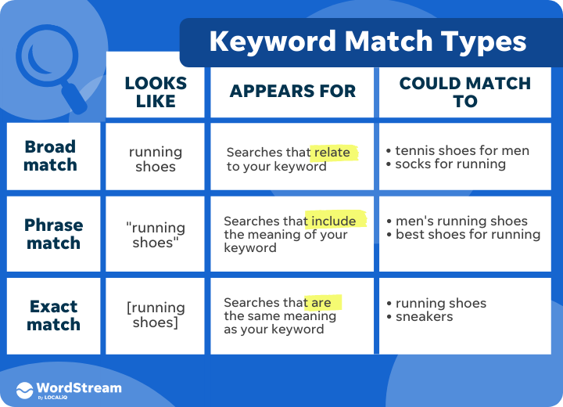

Reference <https://support.google.com/google-ads/answer/7478529?hl=en>

SEO architecture

<https://backlinko.com/hub/seo/architecture>